Concept behind boosting:  
Boosting algorithms work by sequentially training a series of weak learners, where each learner focuses on the mistakes made by its predecessors.

During each iteration of training, AdaBoost increases the weights of misclassified instances and decreases the weights of correctly classified instances. This puts more emphasis on the misclassified instances, forcing the subsequent weak learners to focus on them.

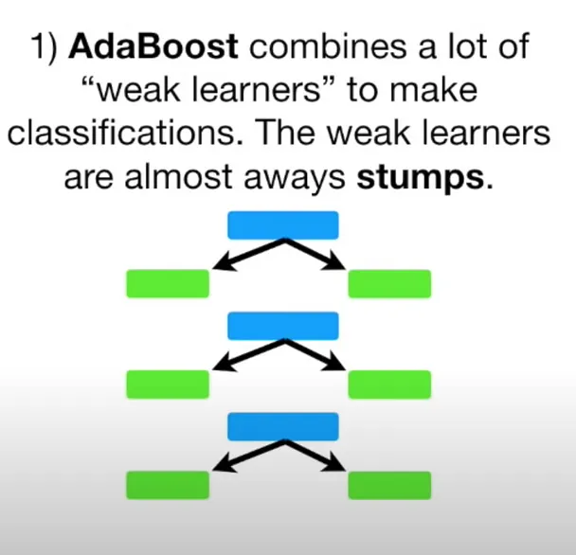

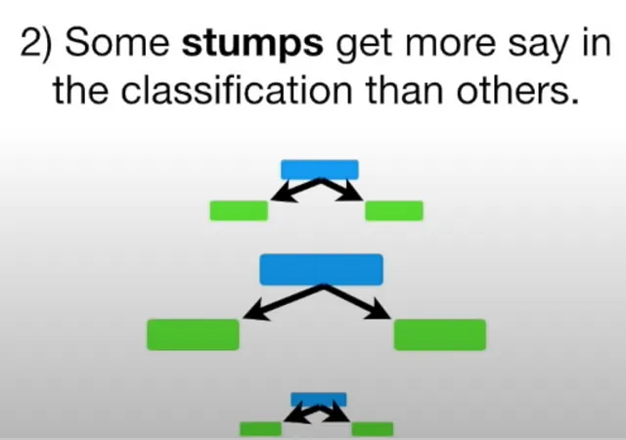

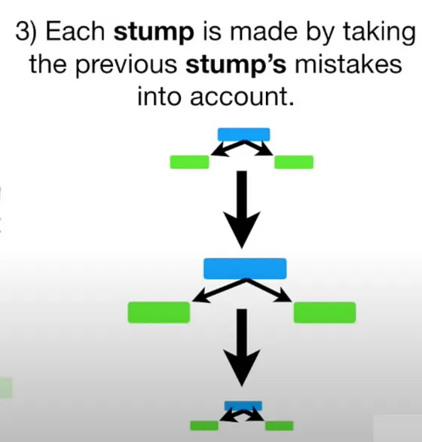

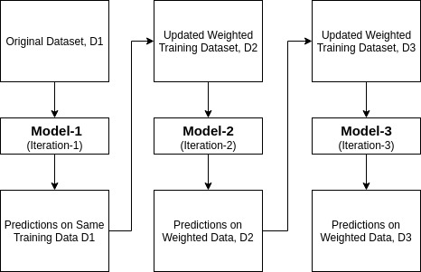

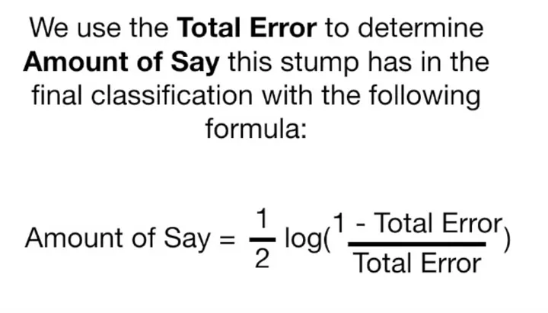

This is the formula for learning rate.

It assigns the higher weight to wrong classified observations so that in the next iteration these observations will get the high probability for classification. This is the formula for deciding the weights

AdaBoost can effectively handle imbalanced datasets by giving more weight to misclassified instances during training.

AdaBoost is a powerful ensemble learning technique that combines multiple weak learners (often simple decision trees or stumps) to create a strong learner.

AdaBoost can handle both categorical and numerical features without requiring preprocessing such as one-hot encoding

There are 2 algorithms:  
1. Adaboost Regressor

2. Adaboost Classifier

Hyperparameters for adaboost regression:

Same as classifier, one additional is:

Loss function, which is used to update weights after each iteration

.

Hyperparameters for adaboost classifier:  
1. **Estimator:**  
The base estimator from which the boosted ensemble is built. Default is Decision Tree Classifier with max-depth as 1. Also called as Decision Stump.

NOTE: Adaboost classifer works well on weak learners algorithm. After their iterative use it performs much better.

2. **n_estimators:**  
The maximum number of estimators at which boosting is terminated.

3. **learning_rate:**

Defined by the formula above

4. algotithm

5. random_state

Adaboost code snippet:  
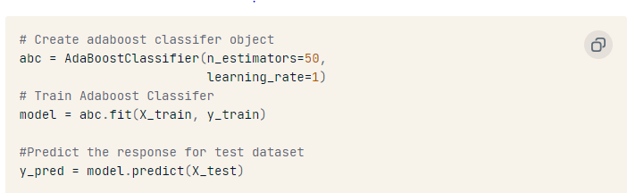

AdaBoost is sensitive to noise data. It is highly affected by outliers because it tries to fit each point perfectly. AdaBoost is slower compared to XGBoost.